Functional Specification Document

PROJECT: MVP 2 Farming Engagement Hub
EPIC: Farmer Segmentation
Functionality: Farmer Contract KPI — Processing and Registration
User Story ID: PA-SEG-001
Functional Specification For: (X) Web Application ( ) Mobile Application
Portal: Back Office PA (Web)
Prototype: BAT - Agri 360 — Figma (segmentation flows)

Contents
- 1. Revision History
- 2. Sign-off
- 3. Process Specification
- 4. User Interface & User Experience
- 5. Policy & Regulatory Requirements
- 6. Technical Requirements
- 7. Positive & Negative Testing

1. Revision History
Date | Name | Change | Version
26/05/2026 | Matheus Kist | Initial document draft | 1.0

2. Sign-off
All screens described in this document are operated by the Backoffice PA User within the Back Office PA portal.
Date | Name | Role

3. Process Specification

3.1 Business Process
In this section you can find the detailed business process description and the corresponding workflows.
- What? Maintain Farmer Contract KPI facts per farmer, crop season, and tobacco culture type. These facts feed segmentation simulations (Loyalty, Quality, Financial, Yield, Scale, and ESG percentage components).
- Who? Backoffice PA User.
- When? Before running segmentation simulations for a crop season; when contract or agronomic facts must be reflected in segmentation.
- Where? Agri360 Web — KPI Data area, Farmer Contract KPI screen.
- Why? Segmentation scoring requires a single, auditable store of contract-level KPI values.
- How? Users filter by crop season, review a grid, edit rows manually, and/or import a bulk file. In a later phase, scheduled jobs will calculate KPIs from integrated sources and freeze values in the same store.

3.2 Phased behaviour
Phase | Behaviour
Phase 1 (MVP) | The screen is the authorised channel for data load: manual grid maintenance and file import. No automatic calculation from contracting or commercialization modules yet.
Phase 2 (target Agri360) | Background routines compute contract KPIs from integrated sources. Results are frozen in the Farmer Contract KPI store with calculation metadata. The UI shows calculated rows as read-only unless the user has override permission; overrides are audited.

3.3 Data requirements
One logical record per Farmer + Crop Season + Culture Type (composite key).
Field | Required | Description
Farmer code | Yes | Business key referencing Farmer master.
Crop season | Yes | Crop season identifier (e.g. year 2025).
Culture type code | No | Tobacco culture type; default FCV when omitted.
Delivered percentage | Yes | Delivered % of contracted volume.
Delivered amount (kg) | Yes | Delivered volume in kilograms.
Contracted amount (kg) | Yes | Contracted volume in kilograms.
IQS | Yes | Integrated Quality Score.
Had NTRM | Yes | Whether farmer had NTRM event.
Had quality mixture | Yes | Whether farmer had quality mixture issue.
Self-funding percentage | Yes | Self-funding %.
Have debt | Yes | Whether farmer has debt.
Yield | Yes | Yield metric for yield KPI scoring.
Scale (ha) | Yes | Planted scale in hectares; used to resolve culture type in simulations.
Reforestation percentage | Yes | ESG reforestation %.
Native forest percentage | Yes | ESG native forest %.
Non-exclusive flag | Derived | Snapshot of farmer non-exclusive status at save/import time.

Import rule: If delivered amount is omitted, the system may derive it from delivered percentage and contracted amount.

4. User Interface & User Experience
In this section you can find details on screens, navigation, CRUD behaviour, validations, and error handling.

4.1 General rules
- A global crop season selector filters the grid and sets the default season for new rows and import.
- Rows are maintained per culture type.
- Access is limited to the Backoffice PA User (view, edit, import; Phase 2 override where applicable).
- All manual changes and imports must be audited (user, timestamp, before/after values).

4.2 SCREEN 01: KPI Data — Farmer Contract KPI (Web)
Screen purpose: List, manually maintain, and bulk-import farmer contract KPI rows for the selected crop season.
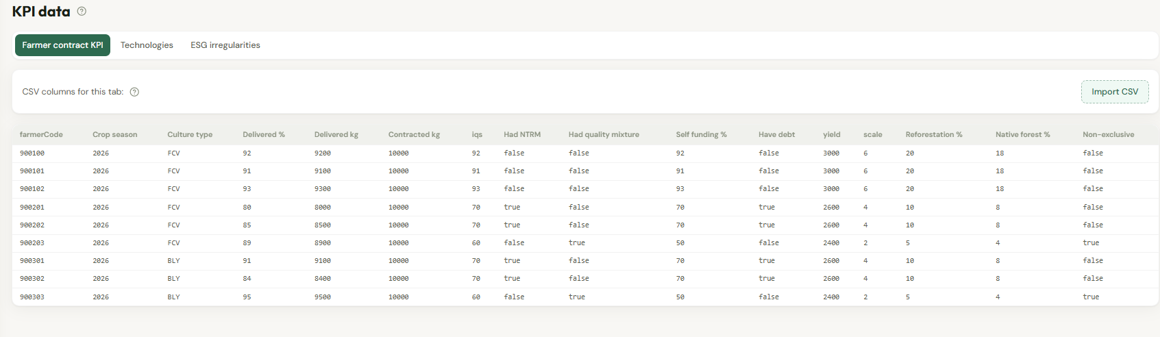
Figure 1 — Wireframe: Farmer Contract KPI screen (tabs for contract, technologies, and irregularities on the same KPI Data area).

4.2.1 Layout
- Header: page title, crop season selector, contextual help.
- Toolbar: Import file, Add row, optional Export.
- Grid: all data fields listed in section 3.3 for the active season.
- Status area: import summary (inserted, updated, errors) with drill-down to row-level messages.

4.2.2 Manual maintenance
- Add row: validate farmer exists; enforce unique Farmer + Season + Culture.
- Edit: inline or form edit with field-level validation.
- Delete: confirmation required; removes KPI record for that key.

4.2.3 File import
- Supported format: CSV (UTF-8) with header row.
- Column headers are matched case-insensitively; spaces and underscores ignored.
- Upsert key: Farmer code + Crop season + Culture type.
- Partial success: valid rows commit; invalid rows reported with row number and message.
- Required columns: Farmer code, Crop season, Delivered percentage, Contracted amount (kg), IQS, Had NTRM, Had quality mixture, Self-funding %, Have debt, Yield, Scale, Reforestation %, Native forest %.
- Optional columns: Culture type, Delivered amount (kg).

4.2.4 Phase 2 UI
- Source column: Manual / Calculated / Override.
- Calculated fields read-only unless override role is granted.
- Display last calculation timestamp and batch reference.

4.3 Dependencies on predecessor user stories
- Farmer master data and crop season catalogue.
- Culture type catalogue.
- Segmentation configuration and simulation user stories consume this data once loaded.

5. Policy & Regulatory Requirements
Segregation of duties: users who import or edit KPI data should not be sole approvers of official segmentation.
Audit trail required for all KPI changes and imports. Farmer personal data in grids must follow data privacy policies.

6. Technical Requirements

6.1 Automations
- Phase 1: none (manual and import only).
- Phase 2: scheduled job to compute and freeze contract KPIs from Agri360 source data per season; notify operations on failure.

7. Positive & Negative Testing

7.1 Test scenarios and acceptance criteria (Web)
ID | Scenario | Expected result
T-01 | Import valid file for a crop season | Rows upserted; summary shows counts.
T-02 | Import unknown farmer code | Row error; other valid rows succeed.
T-03 | Manual edit delivered % | Saved value used in subsequent simulation.
T-04 | Delete row | Row removed from KPI store.
T-05 | Phase 2 calculated row | Fields read-only without override role.

